30 PERINTAH PADA MIKROTIK

1. Mengganti hostname pada mikrotik

*system identity set name=Hostname-Mikrotik*

[](https://1.bp.blogspot.com/-jzKV4ngMfD8/WJ_jnoJdfdI/AAAAAAAAC5g/hx1ym93Eo9gAc17U2oXj3YmRcOZg7SXtwCLcB/s1600/2017-02-01_141152.png)

2. Mengganti password pada mikrotik

*Password :  
------ Masukan password lama :  
------ Masukan password baru :  
------ Masukan password  baru lagi :*

[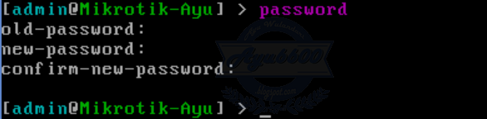](https://3.bp.blogspot.com/-J9hwiUKqDa8/WJ_jnyBSkkI/AAAAAAAAC5k/Qfa1D-GIICEXcsLgkq_6y4pY68DW83utACLcB/s1600/2017-02-01_141312.png)

3. Melihat interface pada mikrotik

*interface print*

[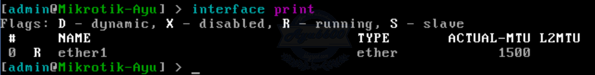](https://2.bp.blogspot.com/-i22oQ6oSSBE/WJ_jnu3aKoI/AAAAAAAAC5c/KF7KVGfEXyELFwjLNCAi6dqspgveBruNgCLcB/s1600/2017-02-01_141419.png)

4. Mengubah nama interoface pada mikrotik

*interface set 0 name=Nama-interface*

[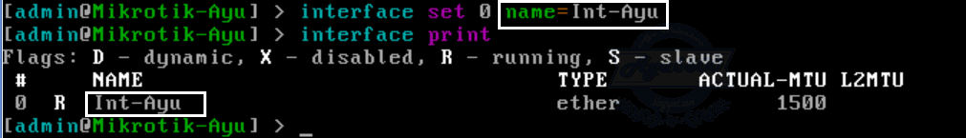](https://3.bp.blogspot.com/-a1Kbk0EnvT4/WJ_joNpUa3I/AAAAAAAAC5o/fRUDu-FQxCMKzZeKFrGLSSNyOOGySDa4gCLcB/s1600/2017-02-01_141555.png)

5.  Melihat paket software pada mikrotik os. Sebelumnya masuk dulu ke directory system package.

*system package*

[](https://1.bp.blogspot.com/-B4txqLlUvZo/WJ_jowxu_FI/AAAAAAAAC54/vorAYkb8AuA5ISOl16XaKle7BjKBwEDfgCLcB/s1600/2017-02-01_141741.png)  
  
Lalu masukan printah print. Print sebenarnya command yang berfungsi untuk melihat atau memperlihatkan suatu hasil dari konfigurasi.

*print*

[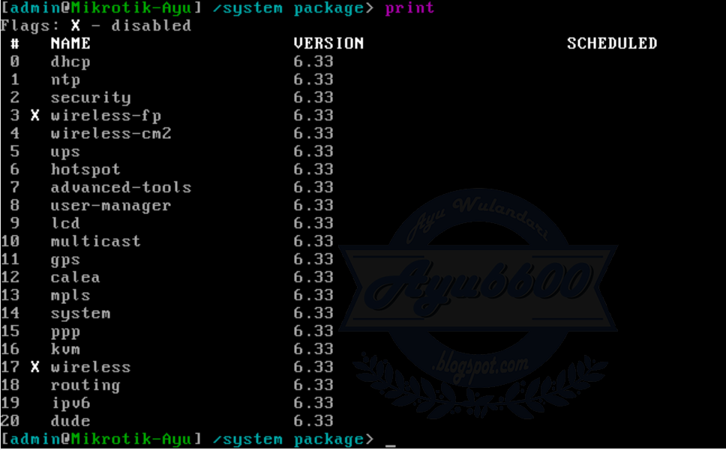](https://4.bp.blogspot.com/-N_KhR_yhV7A/WJ_joYpeIOI/AAAAAAAAC5s/lFLaaFQfolsGyQC7DEXeL38fUm4rR0_0wCLcB/s1600/2017-02-01_141645.png)

6. Keluar dari root directory. Misal kita akan keluar dari directory system package maka kita masukan command " / "

*/*

[](https://1.bp.blogspot.com/-H5gu1AhciW4/WJ_jov2-SrI/AAAAAAAAC5w/SYActlJooj4oHgym9e2tdlUFmA4r0RXfgCLcB/s1600/2017-02-01_141726.png)  
  
7. Menambahkan IP Address

*ip address add interface=ether1 address=0.0.0.0/0*

[](https://3.bp.blogspot.com/-Q_Eo8qzZDpM/WJ_jo_oQ6OI/AAAAAAAAC50/506_fji7jmsd_aa5VKpqY-AuRnadoVOugCLcB/s1600/2017-02-01_141951.png)

8. Melihat ip address

*ip address print*

[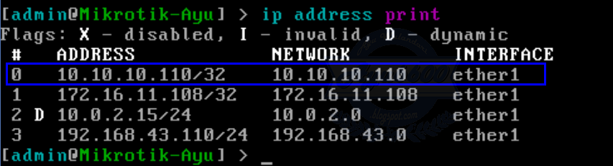](https://1.bp.blogspot.com/-nlwUN62B-Fw/WJ_jpazDCvI/AAAAAAAAC58/4d07RtLlpjMjqEdghl7Uz-S3GuSQxu5IwCLcB/s1600/2017-02-01_142051.png)

9. Menambahkan ip gateway

*ip route gateway=0.0.0.0/0*

[](https://1.bp.blogspot.com/-TvmglE3PpmQ/WJ_jpZZYtnI/AAAAAAAAC6A/iRMN688qPk4QAz-h1FgTVGs_dY1rrMILgCLcB/s1600/2017-02-01_142129.png)

10. Mematikan/shutdown mikrotik

*system shutdown*

[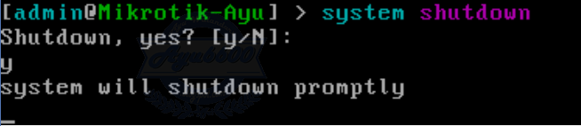](https://4.bp.blogspot.com/-9_UmSupKLH8/WJ_jpiwlefI/AAAAAAAAC6E/bhqctgAl-SU4Ii-wtZ_RUtkHb1uA3vhRQCLcB/s1600/2017-02-01_142202.png)

11. Menyimpan kofigurasi mikrotik

*system backup save*

[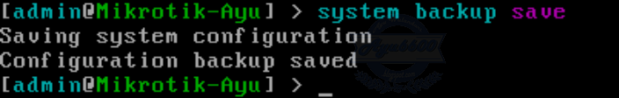](https://3.bp.blogspot.com/-JSvJ5SbmAzw/WJ_jp3yosRI/AAAAAAAAC6I/SlbMnWyZVTkWh36J6FgJQukgOMgqRBRSgCLcB/s1600/2017-02-01_142536.png)

12. Reboot atau restart mikrotik

*system reboot*

[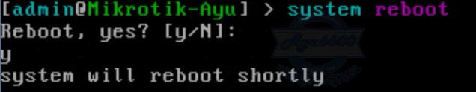](https://1.bp.blogspot.com/-FWXATRzejvA/WJ_jp0TpbhI/AAAAAAAAC6M/5e5JvvBMR_k1hVw1mt7IpXNjyXn4YcqGQCLcB/s1600/2017-02-01_142707.png)

13. Menghapus/mereset konfigurasi mikrotik

*system reset*

[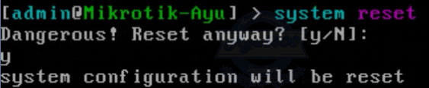](https://1.bp.blogspot.com/-wiOt2ak5Z7o/WJ_jqIBTWcI/AAAAAAAAC6Q/xKMCp9OEduYsXNkmBxLcPtkn5jxOqtu0ACLcB/s1600/2017-02-01_142736.png)

14. Melihat user pada mikrotik

*user print*

[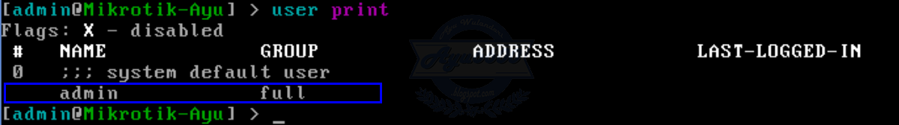](https://2.bp.blogspot.com/-ABhinZrS0JU/WJ_jqUOLJZI/AAAAAAAAC6Y/WQ_U9YNBfCEPx209pjUfykb9lA7bFrUKgCLcB/s1600/2017-02-01_142828.png)

15. Menambahkan user pada mikrotik

*user add name=Nama-User*

[](https://3.bp.blogspot.com/-g4FQXfHGXPI/WJ_jqZYubWI/AAAAAAAAC6U/V8IwNBErAcYsQ9B3wg3SPWZXHxghBn-qACLcB/s1600/2017-02-01_142904.png)

lalu kita lihat user pada mikrotik

*user print*

[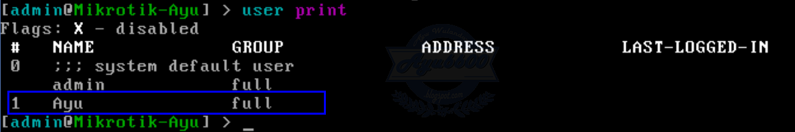](https://3.bp.blogspot.com/-hQrMIwd_zZw/WJ_jqr262EI/AAAAAAAAC6c/-AKI76ge6PIPmA_GvMAKoLrYWIa9X0yQACLcB/s1600/2017-02-01_142934.png)

16. Menambahkan ip dns

*ip dns set servers=0.0.0.0/24*

[](https://4.bp.blogspot.com/-ecItal4MT28/WJ_jq4U3jxI/AAAAAAAAC6g/4N6cs4MHzuYl7U0HzlsLTOhPkJl246dwACLcB/s1600/2017-02-01_143008.png)

17. Melihat IP DNS

*ip dns print*

[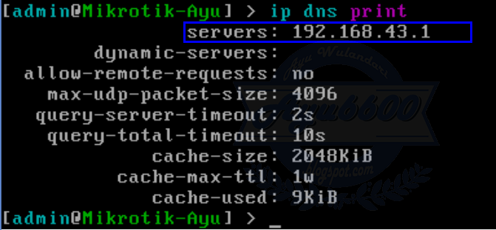](https://3.bp.blogspot.com/-6o2Lj_ugWV0/WJ_jrAXwSvI/AAAAAAAAC6k/C2dR4C55I5sdC-_Xp_PKE6FNFSs7rFqCQCLcB/s1600/2017-02-01_143057.png)

18. Melihat basic status dimikrotik

*system resource print*

[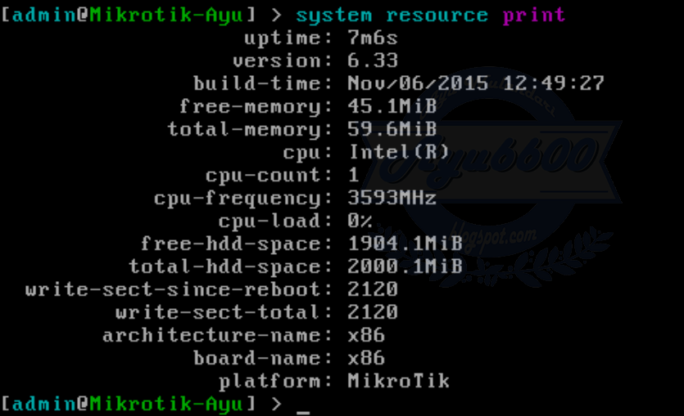](https://4.bp.blogspot.com/-mNOag2FoKU0/WJ_jrXSo3DI/AAAAAAAAC6o/vp6zJFd1FfUvo7bqIUotlc4N7_5g4p0RgCLcB/s1600/2017-02-01_143138.png)

19. Menghapus ip address

*ip address remove 0 (number-urutan dari ip address)*

[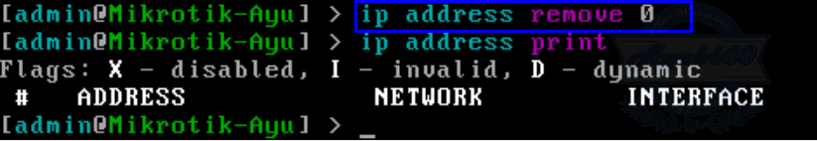](https://3.bp.blogspot.com/-CrMJ-0P2aLk/WJ_jrSWJwLI/AAAAAAAAC6s/1_mFdahBSWANtqUKdnxxrCMehZ_aib2JgCLcB/s1600/2017-02-01_143228.png)

20. Melihat file yang ada dimikrotik

*file print*

[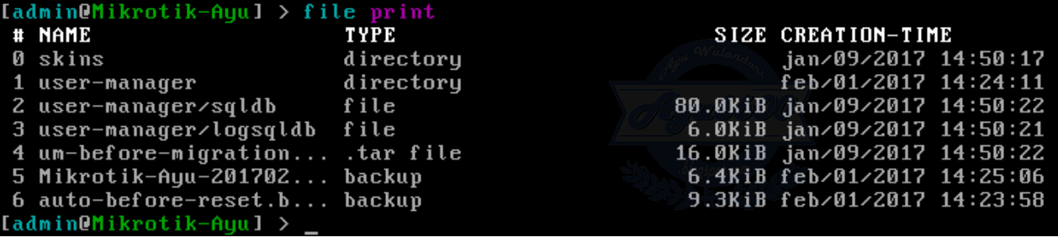](https://1.bp.blogspot.com/-2t4iMy9JuiY/WJ_jry5RQZI/AAAAAAAAC60/GvmZo2weVkoUoSYF1i2dC_UuYFDY2bk6QCLcB/s1600/2017-02-01_143304.png)

21. Melihat hostname pada mikrotik

*system identity print*

[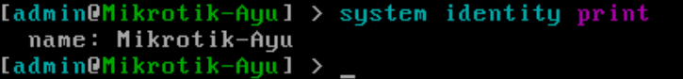](https://4.bp.blogspot.com/-B5Nb75S3A6A/WJ_jrmr617I/AAAAAAAAC6w/_O1fxklSDDAl-fc9E073QJ7ZvZz3BcZTACLcB/s1600/2017-02-01_143339.png)

22. Melihat ip gateway

*ip route print*

[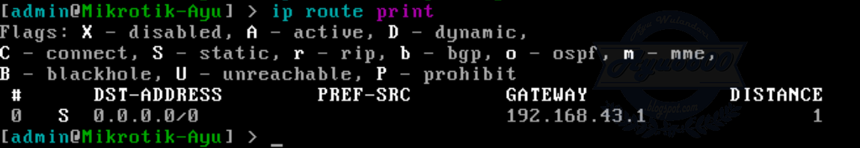](https://1.bp.blogspot.com/-x_UrMPTrP10/WJ_jsUEKzVI/AAAAAAAAC64/PkMEk68i8i87h_PUeloSNAy-y5_ccPcuACLcB/s1600/2017-02-01_143456.png)

23. Masuk ke satu directori

*Contoh : ip route  
               /ip route*

[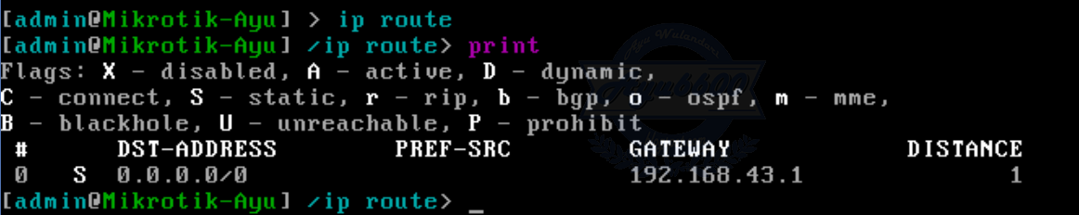](https://4.bp.blogspot.com/-i24psskPMW8/WJ_jsb33QuI/AAAAAAAAC7A/PZQY-oFKcBsTgWSOj9fsak_00y1E9vK2QCLcB/s1600/2017-02-01_143714.png)

24. Naik satu perintah

*..*

[](https://3.bp.blogspot.com/-3PNKp5Z-s8k/WJ_jsXRUHVI/AAAAAAAAC68/rf5-Xfp6FkMXcBZ72Ye3pa-_mgPYTDT4ACLcB/s1600/2017-02-01_143729.png)

25. Tes ping

*ping 0.0.0.0*

[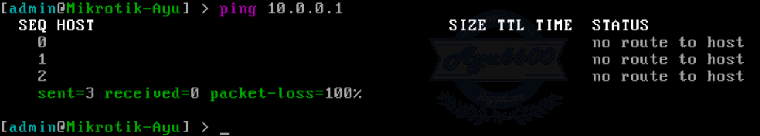](https://3.bp.blogspot.com/-focVkzadIdU/WJ_js_iKqmI/AAAAAAAAC7E/6AgV_lld4zUQJrfjagLeccb4KLxz4vMoQCLcB/s1600/2017-02-01_143837.png)

26. Melihat port pada mikrotik

*ip firewall nat  
.. service-port*

[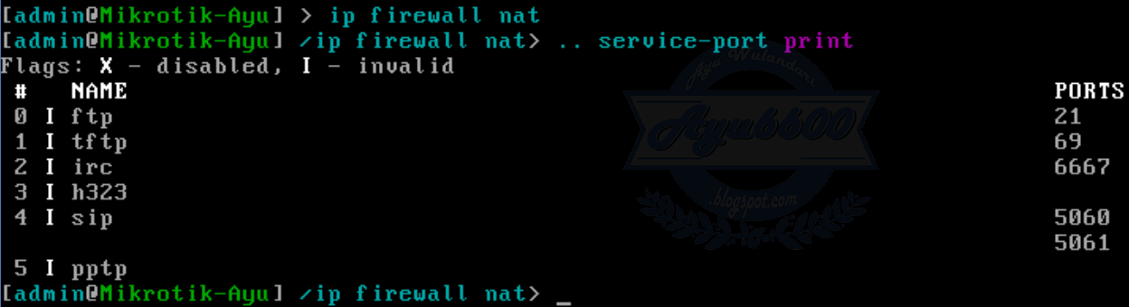](https://3.bp.blogspot.com/-3ocrKUIsfTo/WJ_jtIEctwI/AAAAAAAAC7I/Y8xsFUmvaC0eJQaL80mu4AyygUoPZxU8wCLcB/s1600/2017-02-01_143924.png)

27. Melihat kondisi interface

*interface monitor-traffic*

[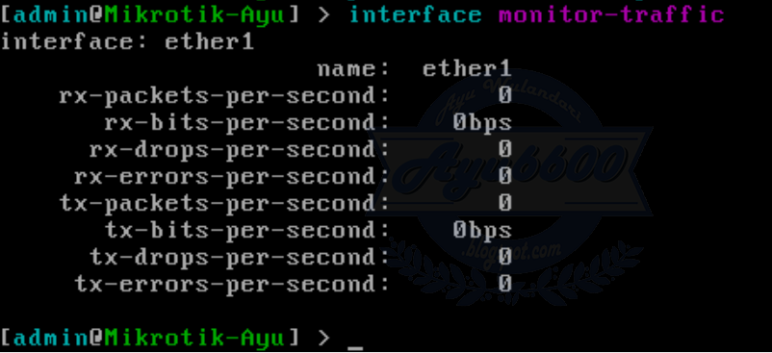](https://2.bp.blogspot.com/-jNh_jwEp6tw/WJ_jtYi8m3I/AAAAAAAAC7M/COt90E6-5EcBv8I4hIdhXOxVVU7c6OcPQCLcB/s1600/2017-02-01_144041.png)

28. Memperlihatkan konfigurasi MikroTik RouterOS ke layar konsol atau ke dalam sebuah file teks (script)

*interface export*

[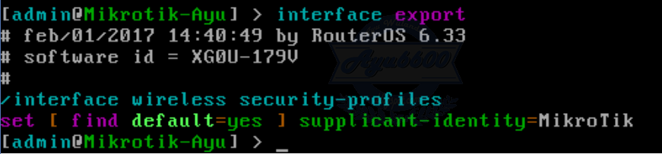](https://1.bp.blogspot.com/-B6M85NjGcjk/WJ_jtvIMe0I/AAAAAAAAC7Q/lha4rWU8tV8Bnzq_wnQVdMFrtyGV23L2gCLcB/s1600/2017-02-01_144108.png)

29.  Membuat safe mode. Safe mode digunakan untuk menhindari adanya kecelakaan pada saat sedang konfigurasi. Masukan perintah lalu tekan CTRL+X

*Example : ip route ctrl+x*

[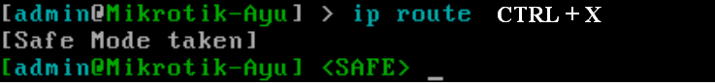](https://1.bp.blogspot.com/-8qA2K1Of59Y/WJ_jt5IorGI/AAAAAAAAC7U/BdOkEVMSKYUY9UhmgLk_u1Rv2GEugWzFgCLcB/s1600/2017-02-01_144233.png)

30. Melihat riwayat konfigurasi pada mikrotik

*system history print*

[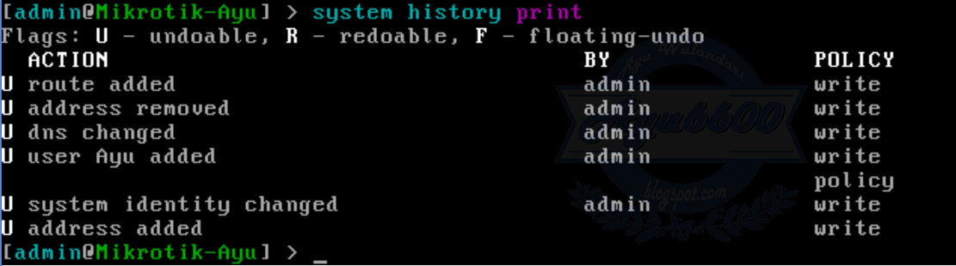](https://1.bp.blogspot.com/-2q55nX_5TkY/WJ_juDhqBqI/AAAAAAAAC7Y/DaUjQM9aObUEG4VL8C7rGTwUM2DsBdkMgCLcB/s1600/2017-02-01_144340.png)